Student: Abilio Junior

SimpliLearn Project: Learner’s Academy

# Sprint Planning

The project was divided in two sprints.

1. Understand the project design the flow of the application according to the requirements
2. Initialize Git and Connect GitHub, Develop the application and document the application.

## Java concepts used in the project

* Java
* Collections
* OOP
* Maven
* Hibernate
* Database
* Servlet
* Exception Handling
* Sort techniques
* HTML
* Annotation

# GIT Repository

GIT - <https://github.com/abgune/LearnersAcademy>

Screenhots

Login

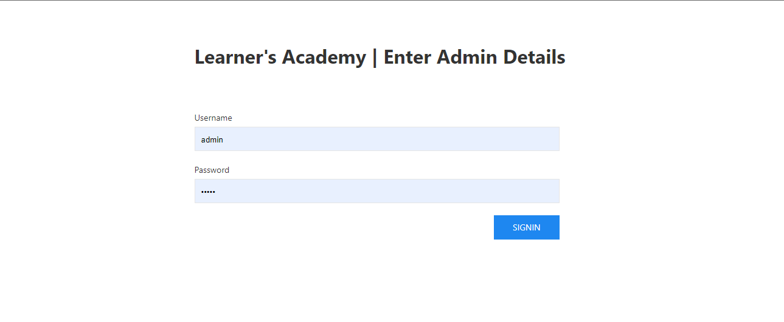

Teachers Menu

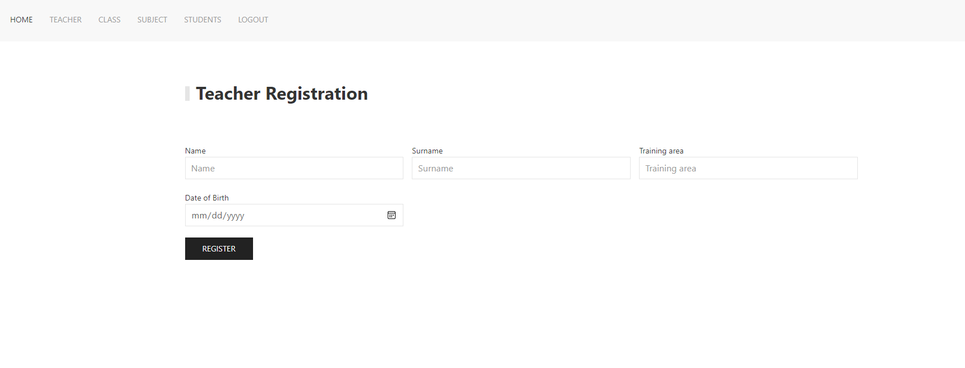

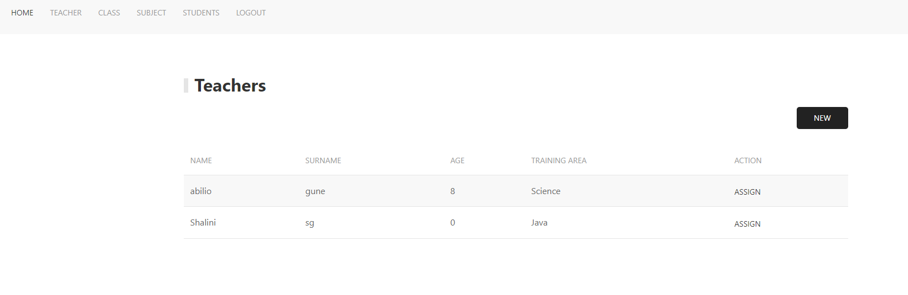

Class Menu

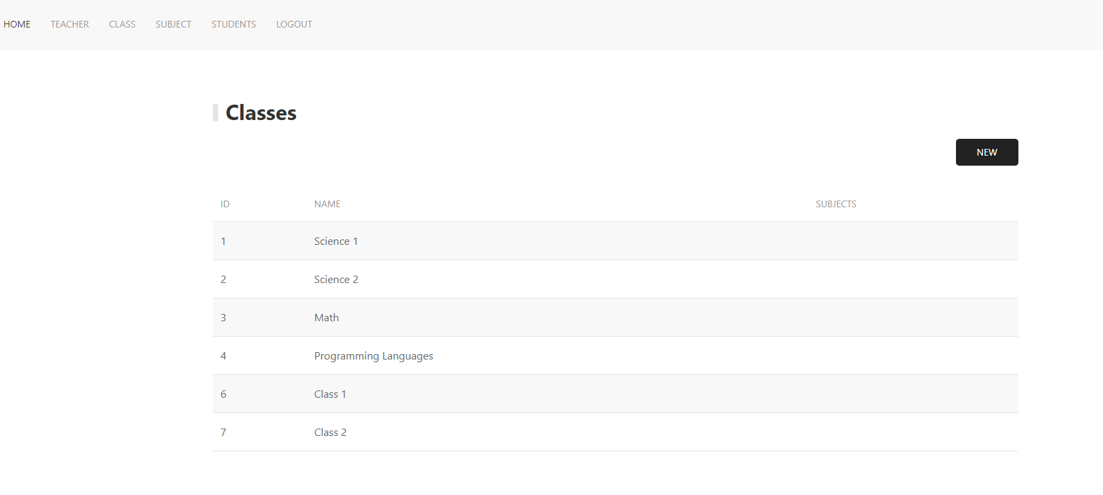

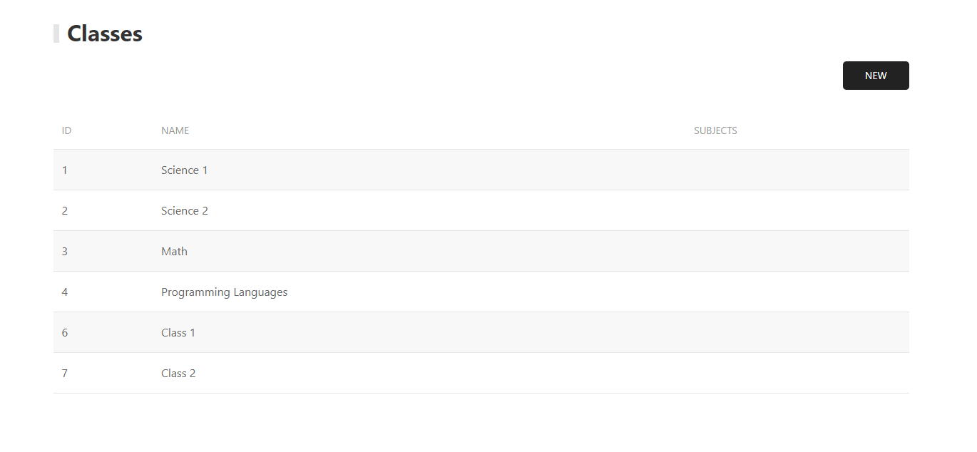

Subjects Menu

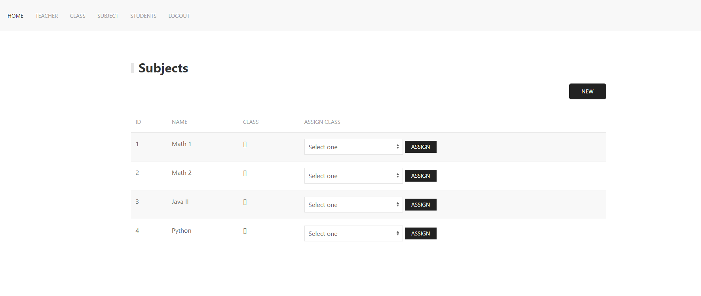



Students Menu

